SMARTBRIDGE
Data Analytics Internship Program
AN INTERNSHIP PROJECT REPORT ON

INDIA'S AGRICULTURAL CROP PRODUCTION ANALYSIS (1997-2021)
Submitted in partial fulfilment of the requirements of the SmartBridge Internship Program By a student of B.Tech - Artificial Intelligence and Machine Learning
Sri Venkateswara College of Engineering, Tirupati

Submitted by
Naveen Kumar Vemana
Academic Year 2025 - 2026

ACKNOWLEDGEMENT
I take this opportunity to express our sincere gratitude to everyone who supported me during the course of this internship project.
I am thankful to SmartBridge for organising the Data Analytics Internship Program and for structuring it in a way that let us learn tools such as Tableau Public hands-on and apply them to a real, publicly available dataset rather than only through theory.
I am equally grateful to the Department of Artificial Intelligence and Machine Learning, Sri Venkateswara College of Engineering, Tirupati, for encouraging us to take up this internship and for providing the academic support needed to complete it alongside our regular coursework.
I would like to thank our internship mentors and coordinators for their continuous guidance and for the feedback given during review sessions, which helped me improve the structure of our dashboard and the clarity of my findings.
I am also grateful to our friends and classmates who tested the dashboard, pointed out confusing visuals, and gave me honest suggestions that made the final output more usable.
Finally, I would like to thank our families for their patience and support throughout this internship, especially during the days we spent cleaning data and rebuilding charts that did not work the first time.
Naveen Kumar Vemana

ABSTRACT
Agriculture continues to be one of the largest contributors to India's economy and employment, yet the data describing crop production is usually spread across long government spreadsheets that are difficult for a common reader to interpret. This project takes the India Agricultural Crop Production dataset covering the period 1997 to 2021 and converts it into an interactive Tableau Public dashboard that can be understood at a glance.
The dashboard combines eight visualizations - two KPI cards showing total production and total yield, a state-wise India map, a year-wise production bar chart, a yield trend line chart, a cultivated area comparison, a production-by-unit-type donut chart, a leading-states bar chart and a season wise pie chart. All the views are connected through Tableau dashboard actions, so that clicking on any state in the map filters every other chart on the dashboard automatically. The same set of views has also been arranged as a Tableau Story so that a viewer can move through the analysis step by step, the way one would read a short report.
The analysis was carried out in stages - the raw data was first cleaned and standardized in Excel, then imported into Tableau, where worksheets were built individually before being combined into the final dashboard. The completed dashboard was tested for correctness of filters, and was published on Tableau Public so that it could be accessed from any browser without needing Tableau Desktop installed.
The resulting dashboard highlights some genuinely useful patterns - for example, that overall production grew fairly steadily across the twenty-five year window, that a small group of southern states account for a disproportionately large share of recorded production because of how certain crops are measured, and that most of the recorded output falls under the “Whole Year” growing season rather than a single cropping season. This report documents the problem statement, the design decisions, the testing process and the final results of the project, along with the advantages, limitations and possible future improvements of the dashboard.

TABLE OF CONTENTS
- Introduction ..................................................................................................................... 6
  - Project Overview / 1.2 Purpose / 1.3 Objectives / 1.4 Scope ...................................... 6
- Ideation Phase ................................................................................................................. 8
  - Problem Statement / 2.2 Empathy Map / 2.3 Brainstorming ....................................... 8
- Requirement Analysis ................................................................................................... 10
  - Customer Journey Map / 3.2 Solution Requirements ................................................ 10
3.3 Data Flow Diagram / 3.4 Technology Stack ............................................................. 11
- Project Design ................................................................................................................ 13
  - Problem-Solution Fit / 4.2 Proposed Solution / 4.3 Solution Architecture ................ 13
- Project Planning ............................................................................................................ 15
- Functional and Performance Testing ........................................................................... 17
- Results ............................................................................................................................ 18
  - Dashboard Overview ............................................................................................... 18
  - Year-wise Agricultural Production (1997-2021) ...................................................... 19
  - Trend of Agricultural Yield (1997-2021) ................................................................. 20
  - State-wise Agricultural Production Distribution ....................................................... 21
  - State-wise Cultivated Area Comparison ................................................................... 22
  - Production Distribution by Unit Type ...................................................................... 23
  - Leading States by Agricultural Production ............................................................... 24
  - Season-wise Agricultural Production ....................................................................... 25
- Advantages and Disadvantages..................................................................................... 26
- Conclusion ..................................................................................................................... 27
- Future Scope ................................................................................................................ 28
- Appendix ...................................................................................................................... 29

1 INTRODUCTION

1.1 Project Overview
This project presents an analysis of India's agricultural crop production over a twenty-five-year period, from 1997 to 2021. Instead of leaving the data in a raw spreadsheet form, the numbers have been organized into an interactive Tableau Public dashboard titled “Comprehensive Analysis of Agricultural Production in India (1997-2021)”. The dashboard is built around two headline KPI figures - total production and total yield - supported by six additional charts that break the data down by year, state, season, unit of measurement and cultivated area.
The dataset used for this project is the same one that was cleaned earlier in the semester as part of our data analytics practice work, and it is included with this report as a supporting Excel file. Cleaning involved removing blank rows, correcting inconsistent state names, and converting text fields into numeric fields so that Tableau could aggregate them correctly.

1.2 Purpose
The purpose of this project is twofold. First, it gives our team hands-on practice with a complete data analytics workflow - starting from a raw government-style dataset, cleaning it, and ending with a published, shareable dashboard. Second, it produces something genuinely useful - a single page that a student, a policy enthusiast, or even a competitive exam aspirant can open in a browser to quickly understand how Indian agriculture has changed since the late 1990s, without needing to open Excel or write any code.

1.3 Objectives
- To clean and structure a 25-year agricultural production dataset so that it is ready for visual analysis.
- To design a dashboard that communicates the overall scale of production and yield at a glance through KPI cards.
- To compare states on the basis of both production and cultivated area, and to identify where the two do not match.
- To show how production has changed year by year, and whether yield (output per unit area) improved over time.
- To publish the finished dashboard on Tableau Public and package the entire exercise as a documented internship project.

1.4 Scope
The scope of this project is limited to descriptive and visual analysis - it does not attempt to build a predictive model or forecast future production. The dataset covers state-level, year-level and season-level aggregates rather than district-level or farmer-level detail, so conclusions in this report are drawn at that level of granularity. The dashboard is designed to be viewed in a web browser through Tableau Public; it does not require the viewer to install any software. Data quality is bound by whatever was reported in the source dataset - a few years, particularly the most recent one in the series, appear to have partial or under-reported values, and this limitation is discussed later in the results section rather than being hidden.

2 IDEATION PHASE

2.1 Problem Statement
Government and open agricultural datasets are usually published as long, multi-sheet spreadsheets containing thousands of rows across states, years, seasons and crop types. While the data itself is valuable, very few people outside of a data analyst actually go through the trouble of opening it, filtering it and charting it themselves. As a result, useful information about how Indian agriculture has grown, which states lead in production, and how yields have changed over time stays locked inside files that most people never open.
The problem this project addresses is: how can a large, technical agricultural dataset be turned into something that a non-technical viewer can explore in a few minutes, without needing any spreadsheet or coding skills, while still being accurate enough to draw real conclusions from?

2.2 Empathy Map
Before deciding on the dashboard layout, we thought about who would actually use something like this and what they would care about.
Farmers - would be interested in which states and seasons are producing the most, mainly to understand broad trends rather than their own individual yield. They think in terms of seasons (Kharif, Rabi) and are more comfortable with visual comparisons than raw numbers.
Government / Policy Officials - need to compare states quickly to decide where support or investment may be needed. They care about production trends over multiple years and want a dashboard that is not cluttered with too many filters.
Researchers - want access to the underlying numbers behind each chart and are more likely to use the exact figures (KPIs, tooltips) rather than just the visual impression.
Students - (including our own review committee) mainly want a clear story - what changed, where, and why - presented in a logical order, which is why we built both a dashboard view and a Story view of the same data.

2.3 Brainstorming - Why Tableau Was Chosen
Our team considered a few different tools before settling on Tableau Public for this project. Excel charts were ruled out early because Excel does not support the kind of cross-filtering (clicking one chart to filter the rest) that we wanted for the map. Power BI was also discussed, but our team did not have consistent access to the desktop application across everyone's laptops, and Power BI's free public sharing options are more limited than Tableau Public's.
Tableau Public was selected mainly because it is free to use, it publishes dashboards to a shareable web link without needing a server, and it has strong built-in mapping support, which was important since state-wise comparison was one of our core requirements. It also supports dashboard actions out of the box, which let us build the click-to-filter behaviour on the India map without writing any code. The trade-off is that Tableau Public dashboards are visible to anyone with the link, so no sensitive data could be used - this was acceptable since our dataset is already publicly available agricultural data.

3 REQUIREMENT ANALYSIS

3.1 Customer Journey Map
A typical viewer opens the published Tableau Public link, and is first shown the dashboard with the two KPI cards (Total Production and Total Yield) at the top right, giving an immediate sense of scale. From there, the viewer's eye is drawn to the India map, where hovering over a state shows its exact production figure. Clicking a state filters the remaining six charts, letting the viewer see that state's year-wise trend, its cultivated area rank, and its season-wise split. A viewer who prefers a guided walkthrough instead can switch to the Story tab, where the same charts are presented one at a time with a short written description above each one, similar to flipping through the slides of a presentation.

3.2 Solution Requirements Functional Requirements
- The dashboard must display total production and total yield as KPI numbers.
- The dashboard must show production by state on a map of India.
- The dashboard must show a year-wise trend of production from 1997-98 to 2020-21.
- The dashboard must show a trend of yield over the same period.
- The dashboard must compare cultivated area across states.
- The dashboard must break down production by unit type (Tonnes, Nuts, Bales).
- The dashboard must rank the leading states by total production.
- The dashboard must show the share of production by growing season.
- Clicking any mark on the India map must filter every other chart on the dashboard (dashboard actions).
- The completed dashboard must be published and accessible through Tableau Public.

Non-Functional Requirements
- Usability - the dashboard should be understandable without a manual, using clear titles and consistent colour coding.
- Performance - filters and dashboard actions should respond within a couple of seconds even with the full 25-year dataset loaded.
- Accessibility - the dashboard must be viewable through a standard web browser without installing Tableau Desktop.
- Maintainability - the underlying Excel data source should be easy to update if a newer year of data becomes available.

3.3 Data Flow Diagram
The diagram below shows how data moves through the project, from the raw dataset to the end user viewing the published dashboard.
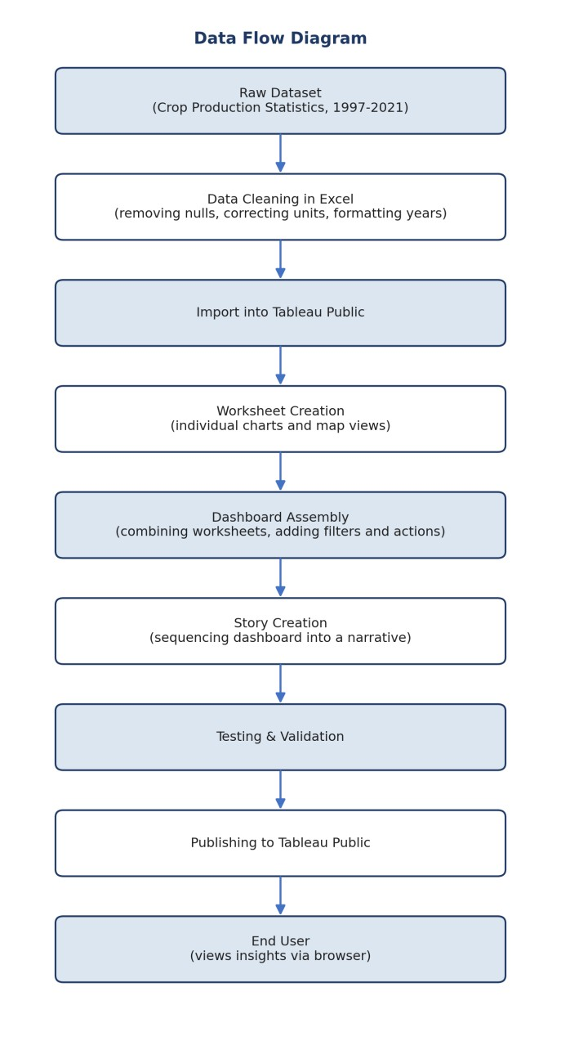
Fig 3.1: Data flow from raw dataset to published dashboard

3.4 Technology Stack
Layer | Technology Used | Purpose
Data Storage | Microsoft Excel (.xlsx) | Storing and cleaning the raw crop production dataset
Data Cleaning | Excel formulas and filters | Removing nulls, fixing state name inconsistencies, unit correction
Layer | Technology Used | Purpose
Visualization | Tableau Public (Desktop for building) | Building worksheets, dashboard and story
Mapping | Tableau built-in Geocoding | Rendering the India state-wise map
Publishing | Tableau Public Cloud | Hosting the dashboard for browser-based access
Documentation | Microsoft Word | Preparing this project report

4 PROJECT DESIGN

4.1 Problem - Solution Fit
The problem identified was that raw agricultural data is hard for non-technical users to interpret. The solution - an interactive dashboard with map-based filtering and a guided story mode - fits this problem because it removes the need for the viewer to understand spreadsheets or write any queries. A single click on a state answers most of the questions a casual viewer would have (how much does this state produce, in which season, compared to its cultivated area), which is exactly the kind of shortcut a spreadsheet cannot offer.

4.2 Proposed Solution
The proposed solution is a single Tableau dashboard, “Comprehensive Analysis of Agricultural Production in India (1997-2021)”, containing seven visualisations and two KPI cards, connected through dashboard actions so that the India map acts as the primary filter for the rest of the view. The same content is also delivered as a four-part Tableau Story for viewers who prefer a step-bystep narrative rather than an interactive free-for-all. Both views are published under one Tableau Public workbook so that either can be shared using a single link.

4.3 Solution Architecture
The architecture below shows the layered structure of the solution, from the raw data source at the bottom up to the published dashboard that the end user interacts with.
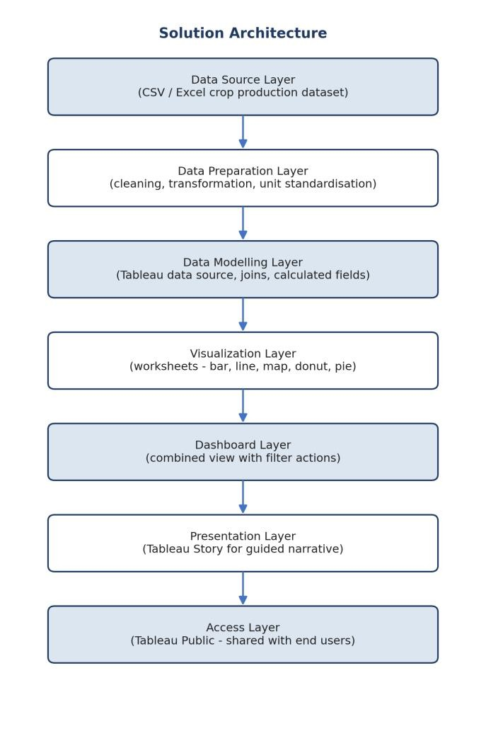
Fig 4.1: Layered solution architecture

5 PROJECT PLANNING
The project was planned as a sequence of stages, moving from understanding the requirement to producing the final documentation. The vertical workflow below summarises the stages in the order they were carried out.
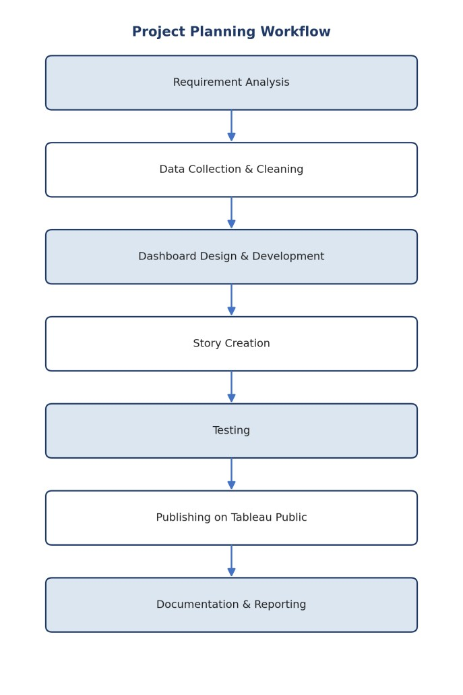
Fig 5.1: Project planning workflow

Stage-wise Explanation
Requirement Analysis - the team listed out what the dashboard needed to show (production, yield, state comparison, season split) before opening Tableau, to avoid redesigning the dashboard midway.
Data Cleaning - the raw dataset was opened in Excel, blank and duplicate rows were removed, state names were standardised, and numeric columns were checked for stray text values.
Dashboard Design & Development - individual worksheets (map, bar charts, line chart, donut, pie) were built one at a time in Tableau and then combined into a single dashboard, with dashboard actions added last.
Story Creation - the same worksheets were reused to build a four-slide Story with short written summaries, so the dashboard could also be viewed as a guided walkthrough.
Testing - filters, tooltips and dashboard actions were checked by clicking through every state and verifying that the numbers on the KPI cards and charts updated correctly.
Publishing - the finished workbook was published to Tableau Public, and the resulting link was tested from a separate device to confirm it loaded correctly outside Tableau Desktop.
Documentation - this report was prepared to record the problem statement, design choices, testing process and final results of the project.

6 FUNCTIONAL AND PERFORMANCE TESTING
Once the dashboard was built, it was tested manually across all its charts and interactions before publishing. The table below summarises the scope of testing that was carried out.
Test Area | What Was Checked | Result
Amount of Data Rendered | All 25 years (1997-98 to 2020-21) and all states load without missing bars | Passed
Utilization of Filters | State, year and season filters correctly narrow down all connected charts | Passed
Calculation Fields | Total production and total yield KPI values match manual totals from the source sheet | Passed
Number of  Visualizations | All 7 charts plus 2 KPI cards render on both the dashboard and story views | Passed
Dashboard Actions | Clicking a state on the map filters the bar, line, donut and pie charts | Passed
Publishing | Published workbook opens correctly from the Tableau Public link on a different device | Passed
Performance | Dashboard responds to filter clicks within roughly 1-2 seconds | Acceptable

Observations
- The 2020-21 bar in the year-wise production chart and the corresponding point in the yield trend line are noticeably lower than the surrounding years; this was traced back to incomplete reporting in the source data for that year rather than an actual production collapse, and has been noted wherever it appears in the results section.
- Tooltip readability on the India map was initially poor on smaller screens; font size and tooltip padding were adjusted during testing to fix this.
- No errors were observed in the dashboard action filters across repeated testing on all 29 states and union territories present in the dataset.

7 RESULTS
This section presents every visualisation from the published dashboard and story, along with an explanation of what each chart shows, an observation drawn from the data, and the key insight it contributes to the overall analysis.

7.1 Dashboard Overview
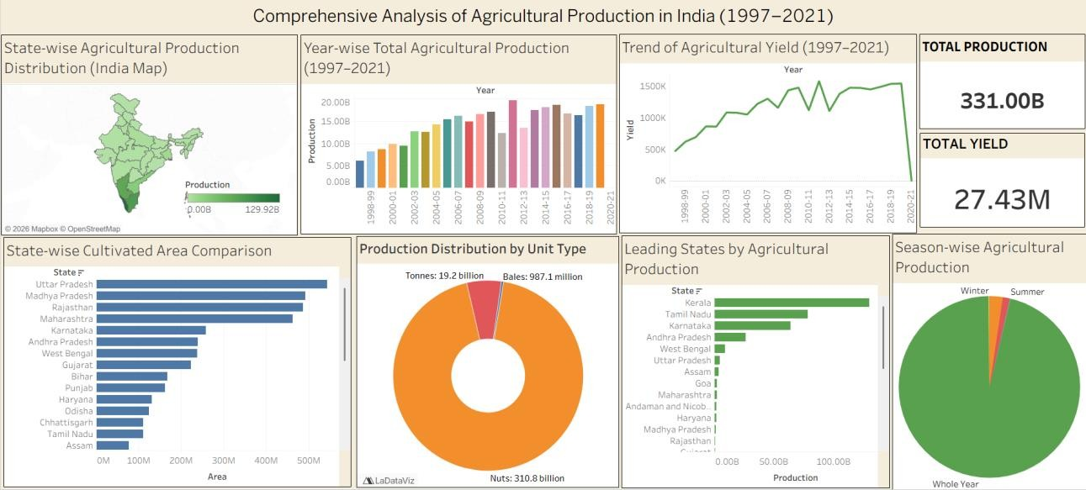

Figure 7.1 Dashboard Overview
This is the complete landing view of the workbook, titled “Comprehensive Analysis of Agricultural Production in India (1997-2021)”. It brings together all seven charts and both KPI cards on a single screen, giving a viewer everything they need at a glance without scrolling.
Observation: the two KPI cards in the top right immediately establish scale - Total Production of 331.00B and Total Yield of 27.43M - before the viewer even looks at a single chart. Below the KPIs, the layout deliberately places the India map on the left, since geography is usually the first thing a viewer wants to orient themselves with, followed by the year-wise and yield trend charts to its right, since time is the second most natural axis of comparison. The bottom row - cultivated area, unit type and leading states - answers more specific follow-up questions once the viewer has absorbed the top row.
Key Insight: presenting the KPIs, map and trend charts together on one screen, rather than spreading them across multiple tabs, means a viewer forms a complete first impression of Indian agricultural production within the first few seconds of opening the dashboard, which was the primary usability goal of this project.

7.2 Year-wise Agricultural Production (1997-2021)
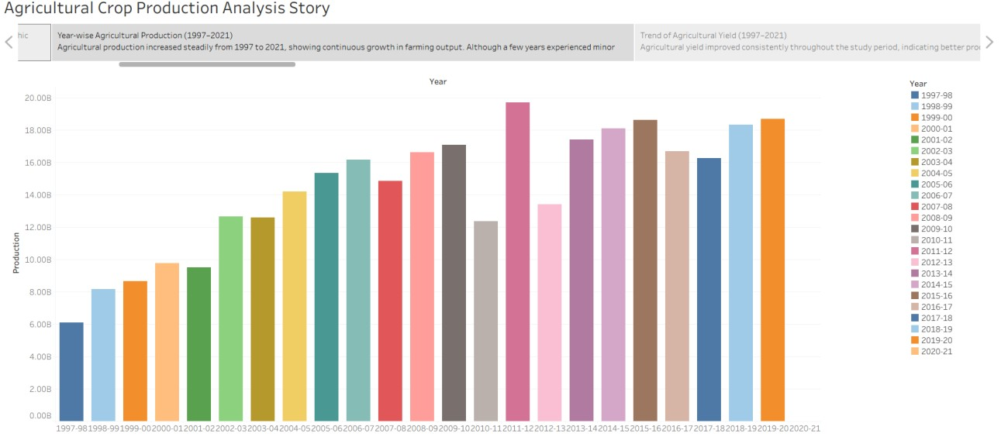

Figure 7.2 Year-wise Agricultural Production (1997-2021)
This bar chart plots total agricultural production for every year from 1997-98 through 2020-21, using a distinct colour for each year to make the sequence easy to scan.
Observation: production rises fairly consistently from around 6 billion units in 1997-98 to a peak of nearly 20 billion units in 2011-12, with a few visible dips - most notably around 2007-08 and 2012-13 - before climbing again through the mid-2010s. The final bar, for 2020-21, is noticeably shorter than the years immediately before it, which does not match the otherwise steady upward pattern of the previous decade.
Key Insight: rather than reading the drop in 2020-21 as a genuine production collapse, our testing (Section 6) traced this to incomplete reporting for that year in the source dataset, since a singleyear fall of that scale after a decade of steady growth is inconsistent with agricultural output patterns. The broader trend across the full 25-year window still supports the conclusion that Indian agricultural production has grown substantially since the late 1990s, roughly tripling between the first and the peak years shown.

7.3 Trend of Agricultural Yield (1997-2021)
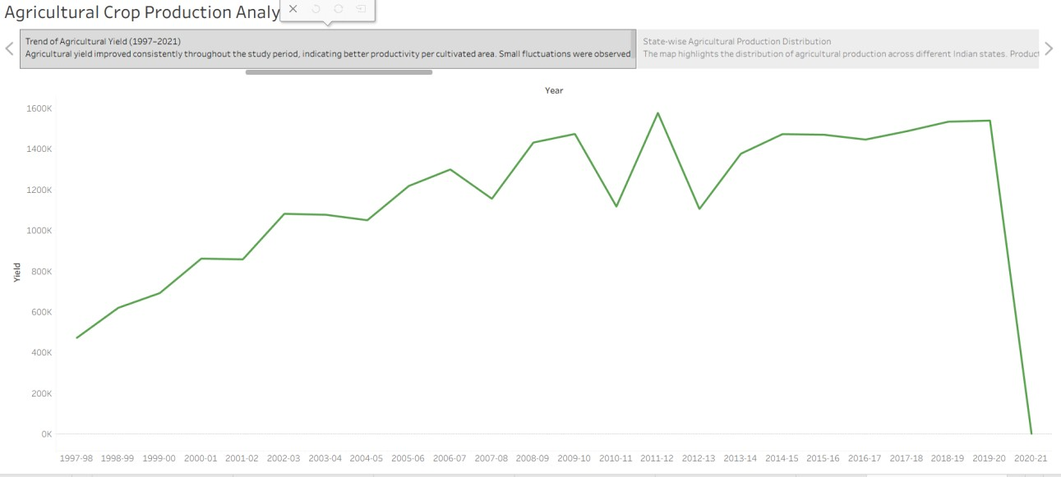

Figure 7.3 Trend of Agricultural Yield (1997-2021)
This line chart tracks agricultural yield - a measure of output per unit of cultivated area - across the same 25-year period, letting us see whether farming became more efficient over time rather than simply larger in scale.
Observation: yield climbs from roughly 470K in 1997-98 to a plateau between 1.4M and 1.6M from around 2014-15 onward, with visible zig-zag dips in individual years such as 2010-11 and 2012-13 that likely correspond to weather-related or regional shortfalls in specific reporting periods. As with the production chart, the final year, 2020-21, shows a sharp fall to near zero, which again points to a data completeness issue for that year rather than an actual yield failure.
Key Insight: excluding the anomalous final year, yield roughly tripled over the study period, which is a meaningfully different story from just “more land was farmed” - it indicates real improvement in output per unit area, likely driven by better seed varieties, irrigation and farming practices over the two and a half decades covered by the dataset.

7.4 State-wise Agricultural Production Distribution
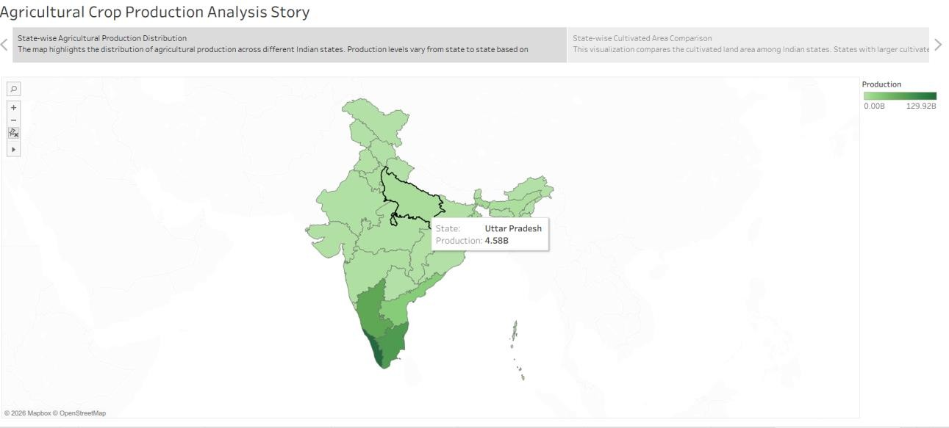

Figure 7.4 State-wise Agricultural Production Distribution
This choropleth map colours each Indian state by its total recorded production, with darker green indicating higher production. Hovering over any state reveals its exact figure - for example, Uttar Pradesh is shown here with a production of 4.58B.
Observation: the darkest shading on the map is concentrated in the southern states, particularly Kerala and Tamil Nadu, rather than in the larger northern agricultural states such as Uttar Pradesh or Punjab that are more commonly associated with India's foodgrain output.
Key Insight: this pattern only makes sense once it is read alongside the unit-type chart (Figure 7.6)
- southern states report a large share of their production in “Nuts” (chiefly coconut), which are counted individually rather than by weight, so their production numbers appear disproportionately large compared to grain-producing states measured in tonnes. This is an important reminder that a single “production” figure can be misleading when it mixes different units of measurement, and any state ranking based on it should be read together with the unit-type breakdown.

7.5 State-wise Cultivated Area Comparison
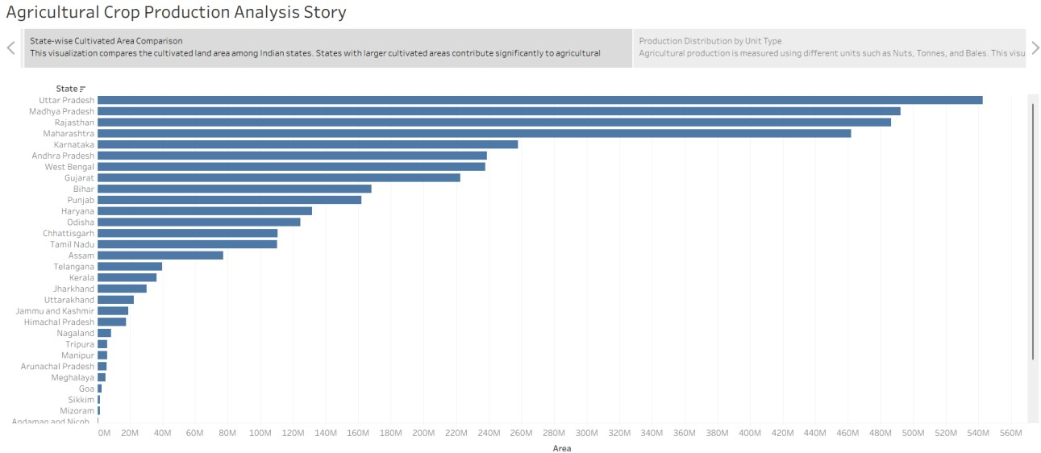

Figure 7.5 State-wise Cultivated Area Comparison
This horizontal bar chart ranks all states by cultivated area, from Uttar Pradesh at the top down to smaller states and union territories such as Sikkim and Mizoram at the bottom.
Observation: Uttar Pradesh, Madhya Pradesh, Rajasthan and Maharashtra occupy the top four positions by a clear margin, each cultivating well over 400 million units of area, while the smallest entries at the bottom of the chart - Goa, Sikkim, Mizoram and Andaman and Nicobar - are barely visible on the same scale.
Key Insight: comparing this chart with Figure 7.4 is where the most useful finding of this project comes from - the states with the largest cultivated area (Uttar Pradesh, Madhya Pradesh, Rajasthan) are not the same states that top the production map (Kerala, Tamil Nadu). This confirms that production, as measured in this dataset, is driven more by crop type and unit of measurement than by sheer farmland size, which is a distinction that would be easy to miss if only one of these two charts were shown on its own.

7.6 Production Distribution by Unit Type
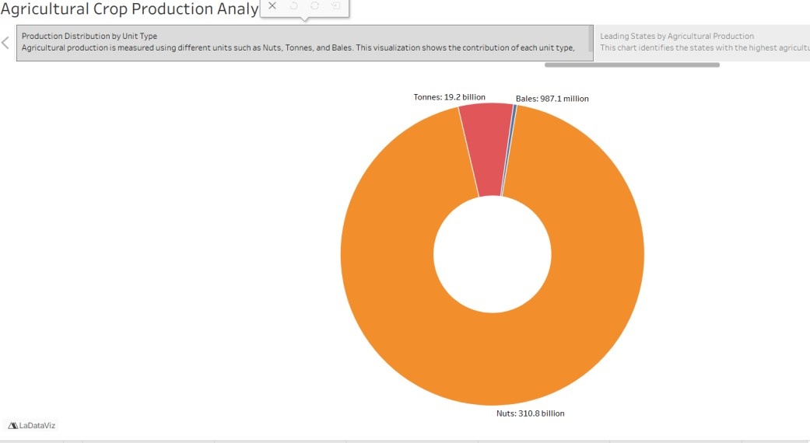

Figure 7.6 Production Distribution by Unit Type
This donut chart splits total production by the unit in which it was recorded - Tonnes, Nuts or Bales - since the source dataset does not use a single consistent unit across all crop types.
Observation: Nuts account for 310.8 billion of the total, visually dominating the donut in orange, while Tonnes contribute 19.2 billion and Bales contribute only 987.1 million, appearing as a thin sliver alongside Nuts.
Key Insight: this chart is the key to correctly interpreting every other production-based chart in this dashboard. Because “Nuts” are counted by number rather than by weight, states that grow large volumes of coconut or areca nut will show enormous “production” figures compared to states that primarily grow grain crops measured in tonnes. Any comparison of states purely by total production, without checking this breakdown, risks comparing apples to oranges - or in this case, quite literally, comparing nuts to tonnes.

7.7 Leading States by Agricultural Production
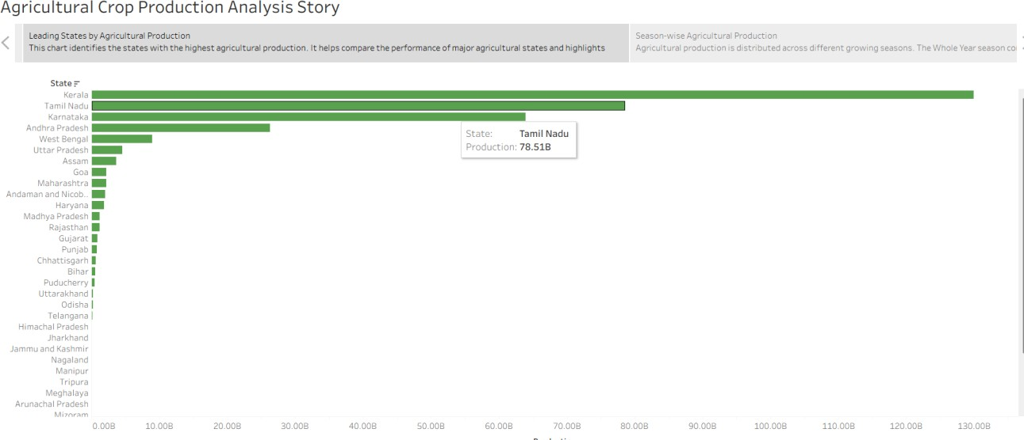

Figure 7.7 Leading States by Agricultural Production
This bar chart ranks Indian states by total recorded production, with Kerala at the top, followed by Tamil Nadu at 78.51B and Karnataka in third place, well ahead of the traditionally grain-heavy northern states.
Observation: the gap between the top three southern states and the rest of the list is large - production falls off sharply after Karnataka, with states like Andhra Pradesh, West Bengal and Uttar Pradesh registering only a fraction of Kerala's total.
Key Insight: read together with Figures 7.4 and 7.6, this ranking is best understood as a ranking driven heavily by nut-based crops rather than a simple measure of “who farms the most.” A viewer using this chart to make real decisions - for instance, a student researching agricultural patterns for an exam, or a policy reader comparing states - should pair it with the unit-type chart to correctly interpret what “leading” means here.

7.8 Season-wise Agricultural Production
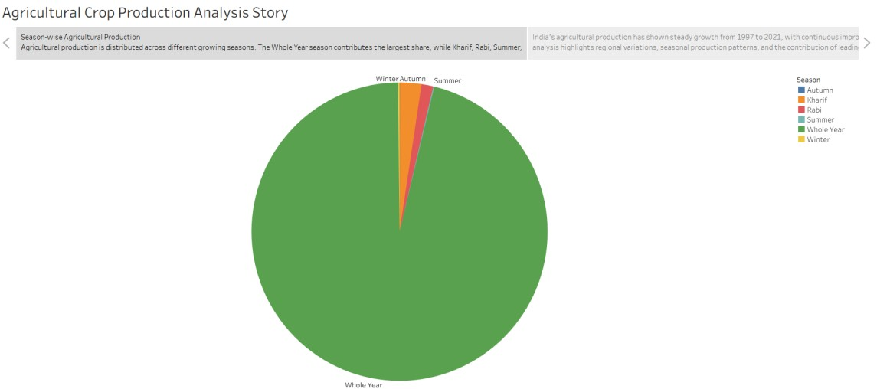

Figure 7.8 Season-wise Agricultural Production
This pie chart splits total production across the growing seasons recorded in the dataset - Kharif, Rabi, Summer, Winter, Autumn and Whole Year.
Observation: the “Whole Year” category overwhelmingly dominates the chart, with Kharif forming a small orange sliver and Rabi an even smaller red sliver; Summer, Winter and Autumn are barely visible at this scale.
Key Insight: this pattern reflects the fact that many of the high-volume “Nuts” crops discussed in Figures 7.6 and 7.7, such as coconut, are harvested throughout the year rather than in a single defined cropping season like Kharif or Rabi, which is how they are classified in this dataset. As a result, this chart should not be read as “most Indian farming happens all year round” in a general sense - it is, again, a reflection of which specific crops dominate the production figures once nutbased output is included.

8 ADVANTAGES AND DISADVANTAGES

Advantages
- Converts a large, technical dataset into a dashboard that can be explored in a browser without any spreadsheet or coding knowledge.
- Dashboard actions allow a viewer to explore any single state in depth just by clicking on the map, without needing separate filters.
- The Story view provides a guided, presentation-style walkthrough for viewers who prefer a narrative over free exploration.
- Published on Tableau Public, so the dashboard can be shared using a single link and viewed on any device with a browser.
- Combining KPIs, a map and multiple chart types on one screen gives both a quick summary and the option to dig deeper.

Disadvantages
- The dataset mixes different units of measurement (Tonnes, Nuts, Bales) without converting them to a common base, which can make raw “production” comparisons misleading if the unit-type chart is not also consulted.
- The most recent year in the dataset (2020-21) appears to have incomplete reporting, which slightly distorts the year-wise and yield trend charts if read in isolation.
- Tableau Public dashboards are visible to anyone with the link, which means this approach is only suitable for public, non-sensitive datasets.
- The dashboard shows aggregated state and year-level figures only; it does not support drilldown to the district or crop level, since that level of detail was not present in the source dataset.

9 CONCLUSION
This project set out to turn a raw, 25-year agricultural production dataset into something a nontechnical viewer could understand within minutes, and the completed Tableau dashboard and story achieve that goal. Building the dashboard also gave our team practical, end-to-end experience of a real analytics workflow - cleaning messy data in Excel, designing individual worksheets, combining them into a linked dashboard using dashboard actions, and finally publishing and testing the result on Tableau Public.
Beyond the technical exercise, the analysis itself produced a genuinely interesting finding - that the states with the largest cultivated area are not the same states that top the production rankings, and that this gap is explained by differences in how crops are measured (Nuts versus Tonnes versus Bales) rather than by farming scale alone. This is exactly the kind of insight that is easy to miss in a raw spreadsheet but becomes obvious once the same numbers are placed side by side as visual charts.
Overall, the project demonstrates that a well-designed dashboard is not just a decorative version of a spreadsheet - it can surface patterns and inconsistencies in the underlying data (such as the incomplete 2020-21 figures) that might otherwise go unnoticed, while remaining simple enough for someone with no data background to explore on their own.

10 FUTURE SCOPE
This project can be extended in several directions if it were to be taken further. The most immediate improvement would be to obtain a complete and corrected figure for 2020-21 (and any later years that become available), since the current dataset appears to under-report that year. Standardising all production figures to a single common unit - for example, converting Nuts and Bales into an approximate tonnage equivalent - would also make state-wise and crop-wise comparisons far more reliable than they currently are.
A second direction would be to add crop-level and district-level detail if such data becomes available, since the current dashboard is limited to state and year-level aggregates. This would allow a viewer to answer more specific questions, such as which individual crop is driving a particular state's high production figure, rather than only seeing the state-level total.
Finally, the dashboard could be extended with a simple forecasting layer - for instance, a basic trend projection for the next few years - once enough clean, consistent yearly data is available, turning this from a purely descriptive analysis into one that also supports forward-looking planning.

11 APPENDIX
Dataset: India Agricultural Crop Production Analysis (Cleaned), 1997-2021 - Excel workbook submitted alongside this report.
Tableau Public Link: https://public.tableau.com/app/profile/ (workbook: Comprehensive Analysis of Agricultural Production in India (1997-2021))
GitHub Handle: naveen-kumar-9515
LinkedIn: Naveen Kumar

